Sent via email only

Registered Nurses’ Association of Ontario
158 Pearl Street
Toronto ON
M5H 1L3

Dear Ms. Seidman-Carlson and Ms. Grinspun,

On behalf of ANDSOOHA (Ontario Public Health Nursing Management) and Ontario Public Health Chief Nursing Officers, we are writing in response to the recent release of RNAO's Enhancing Community Care for Ontarians; Three Year Plan (ECCO). It is our understanding that RNAO is currently seeking consultation to ECCO and as leaders in public health nursing we are alarmed by RNAO’s interpretation of the model and believe such direction is not in the best interest of the health of Ontarians.
In a recent teleconference presentation about the ECCO model, RNAO clearly indicated that the organizational move of Public Health under the LHIN structure is included in next steps towards operationalization of ECCO. This position demonstrates a disregard of the significant evidence in commissioned reports and recommendations of public health associations such as alPHa, OPHA and past Ontario Chief Medical Officer of Health, Dr. Sheela Basrur. As well, there is a notable absence of inclusion of public health nursing leaders and other sector leaders such as COMOH in the consultations during the development of the ECCO report.
In addition, public health nurse leaders are concerned that RNAO’s recommendation appears to be based on a fundamental lack of understanding of the function and purpose of public health. The complexity and uniqueness of public health is aptly described by Dr. Brent Moloughney i.e. "Unlike other health organizations, individual -focused health service provision is not the primary focus of public health. The provision of clinical, individual-focused services is only one of the several programmatic approaches applied by public health organizations to fulfill their mandate." Moloughney, B. (2007). The primary focus of public health is the health and well being of the whole population by addressing the determinants of health and through the promotion and protection of health and the prevention of illness (Ontario Ministry of Health and Long Term Care, (2008) Ontario Public Health Standards).

Dr. Sheela Basrur, among other public health leaders, recognized the importance of maintaining the independence of public health, strengthening the public health system, and strengthening the resource base for public health by increasing the provincial share of funding for local public health units. These goals embedded in “Operation Health Protection” and Capacity Review committee report “Revitalizing Ontario’s Public Health Capacity” will be jeopardized by integration of public health under the LHINs.
Before moving forward with the ECCO report, we request that the Board direct staff to conduct a more extensive review of the existing evidence (references/attachments) and conduct a consultation with public health nursing leadership as well as other sector leaders, similar to what was completed for the acute, primary and long term care sectors.
It is the opinion of ANDSOOHA- Public Health Nurse Management and Ontario Public Health Chief Nursing Officers that the shift of public health out of the current municipal structure to be part of the LHIN structure is not good for Ontarians and will not achieve the Minister’s goal of “making Ontario the healthiest place in North America to grow up and grow old.” As RNAO members, we are confident that you and the RNAO board will consider our concerns and requests expressed in this letter. We look forward to future conversation.

Karen Quigley-Hobbs Jean Nesbitt
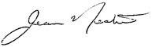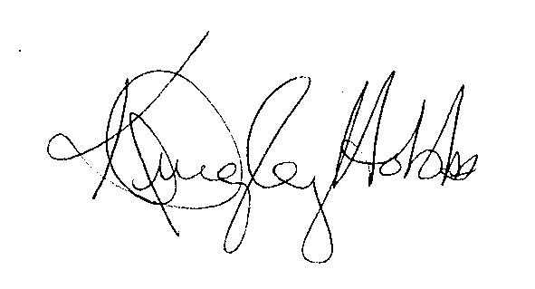
President, ANDSOOHA Chair, Ontario Public Health
Chief Nursing Officers

Cc:
RNAO Board of Directors
Jennifer Tonn – CHNIG President

References
Association of Local Public Health Agencies. (2010). ALPHA Resolution A10-9. Retrieved January 16, 2013 from http://c.ymcdn.com/sites/www.alphaweb.org/resource/collection/5F5ADAAC- 3DD4-40F7-8DA4-FA24DDCC88C1/alPHa_resolution_A10- 9_LocalPublicHealthIntegratedNetworks.pdf
Moloughney, B. (2007). A Discussion Paper on Public Health, Local Health Integration Networks, and Regional Health Authorities. Prepared for Ontario Public Health Association. Retrieved January 16, 2013 from http://www.opha.on.ca/resources/docs/OPHA-DiscussionPaper-PH-LHINs- Oct07.pdf
Ontario Ministry of Health and Long-Term Care (2008). Ontario Public Health Standards. Retrieved January 16, 2013 from http://www.health.gov.on.ca/en/pro/programs/publichealth/oph_standards/docs/o phs_2008.pdf
Ontario Ministry of Health and Long-Term Care (2006). Revitalizing Ontario’s Public Health Capacity: The Final Report of the Capacity Review Committee. Retrieved January 16, 2013 from http://www.health.gov.on.ca/en/common/ministry/publications/reports/capacity_re view06/capacity_review06.aspx
Clemens, Sara (RNAO) (2012). Visionary Leadership: Charting a Course for Nursing in Ontario. December 18, 2012. Retrieved on January 18, 2013.

